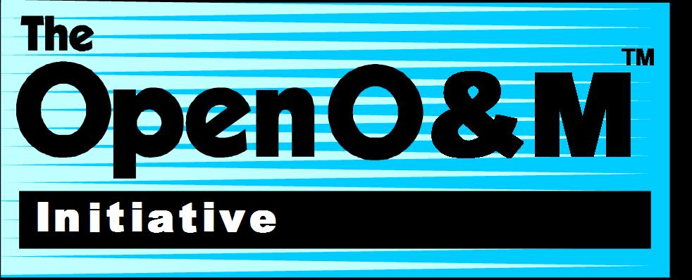
The OpenO&M Initiative was formed by the leadership teams from key industry standards organizations with a shared vision for enabling open standards-based interoperability in global industry. While the individual standards associated with the initiative provide valuable elements of interoperability within certain functional domains and/or industry groups, harmonization of the key standards was seen to be the key to establishing the levels of interoperability needed in an ever more complex and interrelated world.

Most Operations and Maintenance (O&M) related activities, such as those focused on Manufacturing Operations Management, have historically concentrated on enabling interoperability for people processes and systems within a single enterprise (intra-enterprise) and they have usually focused on a single industry sector. The OpenO&M Initiative took a somewhat different approach, addressing O&M interoperability requirements on a cross industry basis spanning manufacturing, fleets (including military) and facilities with a harmonized approach to configuration management and linkages to the Design/Engineering systems domain. This strategy was seen as being particularly critical for Physical Asset Management and Operational Risk Management related domains within O&M, but it also provides the foundation for a more sustainable approach to O&M systems implementation and sustainment.

In almost every major industry and enterprise, groups of subject matter experts, work independently on designing, implementing and sustaining processes and systems in their individual domains of expertise including Operations Management, Enterprise Business Systems and Engineering Systems. Since the OpenO&M Initiative works with such a broad cross section of industry with many equally legitimate points of view, harmonization has always been seen as a critical strategy and the OpenO&M Common Interoperability Registry (CIR) is a cornerstone of that harmonization. The physical assets which support operations have life-cycles spanning multiple enterprises, operating environments and maintenance organizations, so the OpenO&M CIR has been designed to provide the needed level of tracing and tracking for those assets on a multi-enterprise basis. Thus, amongst its other design goals, the OpenO&M CIR and its physical asset management extensions provides a comprehensive approach to the management of unique identifiers related to physical assets and the roles they may play throughout their life-cycle. When used in conjunction with ISO 15926, the combination provides the key elements for gaining semantic alignment on all enterprise information, managing classes of O&M information, tracing and tracking unique instances of O&M information and binding O&M processes and systems to each other in an operational environment.

OpenO&M Common Interoperability Registry (CIR) Specification with

MIMOSA CCOM Extensions for Physical Asset Management

Technical Scope
The OpenO&M Common Interoperability Registry (CIR) Specification provides a standards-based, vendor-neutral approach for the construction of an object registration server for a single facility, an entire enterprise, or multiple enterprises. The specification details an XML language and a set of Web Services which an OpenO&M CIR Registry Server must support so that source client systems throughout an enterprise can harmonize and cross-reference their internal system objects. The server supports the harmonization of distinct, semantically-meaningful identifiers for the same tangible objects across multiple system by generating a non-semantically meaningful 128-bit OpenO&M Common Interoperability Registry ID (CIRID). The CIRID must be generated in compliance with the time-based generation mechanism of the Universal Unique IDentifier (UUID) definition found in ISO/IEC 9834-8:2005.

In compliance with ISO/IEC 9834-8, UUIDs are an octet string of 16 octets (128 bits). The 16 octets can be interpreted as an unsigned integer encoding, and the resulting integer value can be used as the primary integer value (defining an integer-valued Unicode label) for an arc of the International Object Identifier tree under the Joint UUID arc. This enables users to generate object identifier and OID internationalized resource identifier names without any registration procedure. UUIDs are also known as globally unique identifiers (GUIDs).

UUIDs were originally used in the network computing system (NCS) and later in the Open Software Foundation's Distributed Computing Environment (DCE). UUIDs forming a component of an OID are represented in ASN.1 value notation as the decimal representation of their integer value, but for all other display purposes it is more usual to represent them with hexadecimal digits with a hyphen separating the different fields within the 16-octet UUID. In its CIRID canonical form, this 16-octet UUID consists of 32 hexadecimal digits, displayed in 5 groups separated by hyphens, in the form 8-4-4-4-12 for a total of 36 characters(32 digits and 4 '-'). For example:

550e8400-e29b-41d4-a716-446655440000

When generated according to the time-based version mechanism defined in ISO/IEC 9834-8:2005 , a UUID is guaranteed to be different from all other UUIDs generated before 3603 A.D. These UUIDs can be generated at the rate of 10 million per second per machine if necessary. The number of theoretically possible UUIDs is 216*8 = 2128 = 25616 or about 3.4 × 1038. To understand the quantity which this represents, 1 trillion UUIDs would have to be created every nanosecond for slightly more than 10 billion years to exhaust the number of UUIDs.

For UUIDs generated within a single computer system, a 60-bit time-stamp (used as a clock value) with a granularity of 100 nanoseconds, based on coordinated universal time (UTC) is used to guarantee uniqueness over a period of approximately 1600 years. For UUIDs generated with the same time-stamp by different systems, uniqueness is obtained by use of 48-bit media access control (MAC) addresses, specified in ISO/IEC 8802-3 (this is used as a Node value). (These addresses are usually already available on most networked systems, but are otherwise obtainable from the IEEE Registration Authority for MAC addresses). Alternative ways of generating Clock and Node values are specified for the time-based version if UTC time is not available on a system, or if there is no MAC address available.

No centralized authority is required to administer UUIDs but central registration of self-generated UUIDs, and automatic generation and registration of UUIDs, is provided. Centrally generated UUIDs are guaranteed to be different from all other UUIDs centrally generated. Registered UUIDs are guaranteed to be different from all other registered UUIDs.

The CIRID UUID is used only for harmonization between systems, so that each source system can continue to utilize their existing unique identifier for an identical object. In addition, the specification supports the harmonization of semantically identical properties from multiple systems associated with an object by generating a CIRID for each semantically identical property. This allows each source system to continue their existing unique identifier for a property.

MIMOSA’s OSA-EAI Common Conceptual Object Model (CCOM) V3.3 provides a standards-based vendor-neutral approach for the use and extension of the OpenO&M Common Interoperability Registry for the tracking of serialized Assets – including fixed equipment, mobile assets, documents, and software – to cover a broad spectrum of applications including including:

- As-designed OEM product identification (model/part identification)
- As-built OEM serialized manufactured product identification (asset identification)
- Product component breakdown structure identification
- Tangible item/asset tracking and tracing (including functional segment identification)
- Asset configuration/calibration management
- Asset control tag location identification
- Asset usage/health/condition monitoring tag identification

Technical Features
- Standardized UML class model definition
- Standardized XML schema language definition
- Independent of unique identification number chosen by a given system, including ISO/IEC 1549,
- Support for association with ISO 15926 objects
- Support for harmonization/cross-reference of any object
- Support for harmonization/cross-reference of any property applicable to objects
- Support for existing systems supporting the MIMOSA CRIS V3.2 registry identification using Enterprise Unique Integration Code, Site Unique Integration Code, Asset Unique Integration Code, and Segment Unique Integration Code

Benefits
- Supports the integration of RFID and sensor integration platforms and applications with business enterprise systems
- Supports Web-based tools for an integrated RFID system from sense, read, and write parameters to device ID, location, type, and role concepts
- Supports an integrated ID and business process context for enterprise systems
- Supports the evolution of various RFID and barcode technology related to a specific asset
- Supports all unique RFID or other ID numbers utilized now and in the future by a given system, including ISO/IEC 15459, EPCglobal GS1-EAN, Ubiquitous IDs (ucodes), URIs, and Internet Protocol IPv6
- Supports as-designed OEM product identification/harmonization and as-built OEM serialized product identification/harmonization
- Supports product component breakdown structure identification/harmonization
- Supports tangible item/asset tracking and tracing (including functional segment identification/harmonization)
- Supports asset configuration/calibration management
- Supports asset control tag location identification/harmonization
- Supports asset usage/health/condition monitoring tag identification/harmonization

